DATANEX
Internship Program
Weekly Task Report — Week 3
Web Vulnerabilities (Finding the Open Doors)
OWASP Juice Shop — SQL Injection & Cross-Site Scripting (XSS)
Full Name | Abdullah Khan
Internship Domain | Cyber Security
Email Address | abdullah.aamir392005@gmail.com
Phone Number | 0312-1411787
Submission | Name_Domain_Weekly 3

1. Task Overview
This week's task introduced two of the most common web application vulnerabilities encountered in cyber security: SQL Injection and Cross-Site Scripting (XSS). Both were practiced on OWASP Juice Shop, an intentionally vulnerable web application built and maintained by the OWASP Foundation specifically for legal, hands-on security training.
The objective was to successfully complete two beginner-level challenges on the Juice Shop platform: bypassing the login form using a SQL Injection payload, and triggering a Cross-Site Scripting (XSS) payload through the search functionality. Both challenges were confirmed as solved via Juice Shop's built-in Score Board.

2. Environment & Tools
• Operating System (client): Windows 10
• Target application: OWASP Juice Shop (bkimminich/juice-shop)
• Deployment method: Docker Desktop (local container)
• Access URL: http://localhost:3000
• Browser: Google Chrome

3. Methodology & Implementation
Juice Shop was deployed locally using Docker, which runs the vulnerable application in an isolated container so that testing has zero risk to any real system or network. Each challenge below was carried out directly against this local instance and verified as solved using the application's built-in Score Board, which tracks challenge completion in real time.

Challenge 1 — SQL Injection: Login Bypass
SQL Injection is a technique where an attacker inserts malicious input into a query field so that it alters the logic of the underlying database query. In this challenge, the goal was to log into the application as the administrator account without knowing the actual password.
The login form likely constructs a query on the backend similar to: SELECT * FROM Users WHERE email = '<input>' AND password = '<input>'. By supplying a crafted email value, the structure of this query can be changed so that the password check is bypassed entirely.
Email field : ' OR 1=1--
Password field: x (any value)
The single quote closes the intended string, OR 1=1 introduces a condition that is always true, and the double-dash (--) comments out the remainder of the original query, including the password check. As a result, the database returns the first matching user record without ever validating a password.
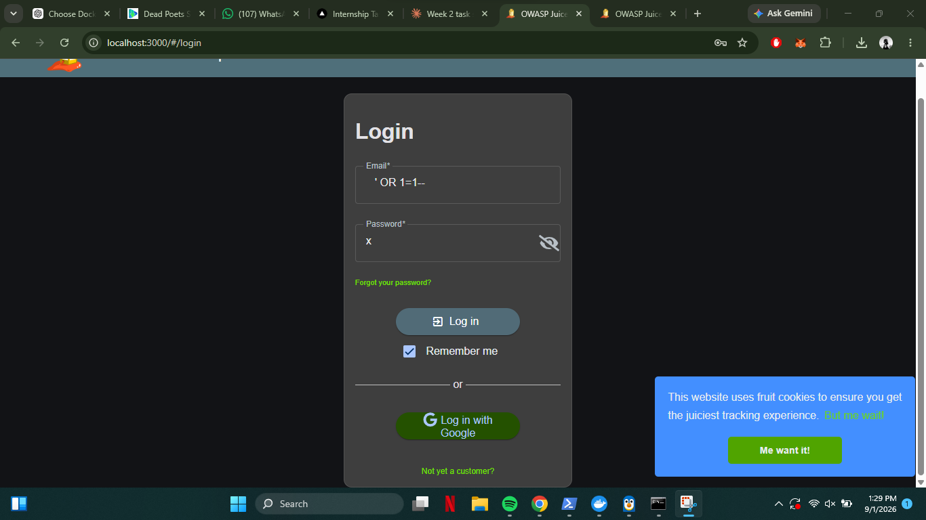
Figure 1: SQL Injection payload entered into the login form's email field.
After submitting the form, the application logged the session in as the administrator account (admin@juice-sh.op), and the Score Board immediately confirmed the challenge 'Login Admin' as successfully solved.
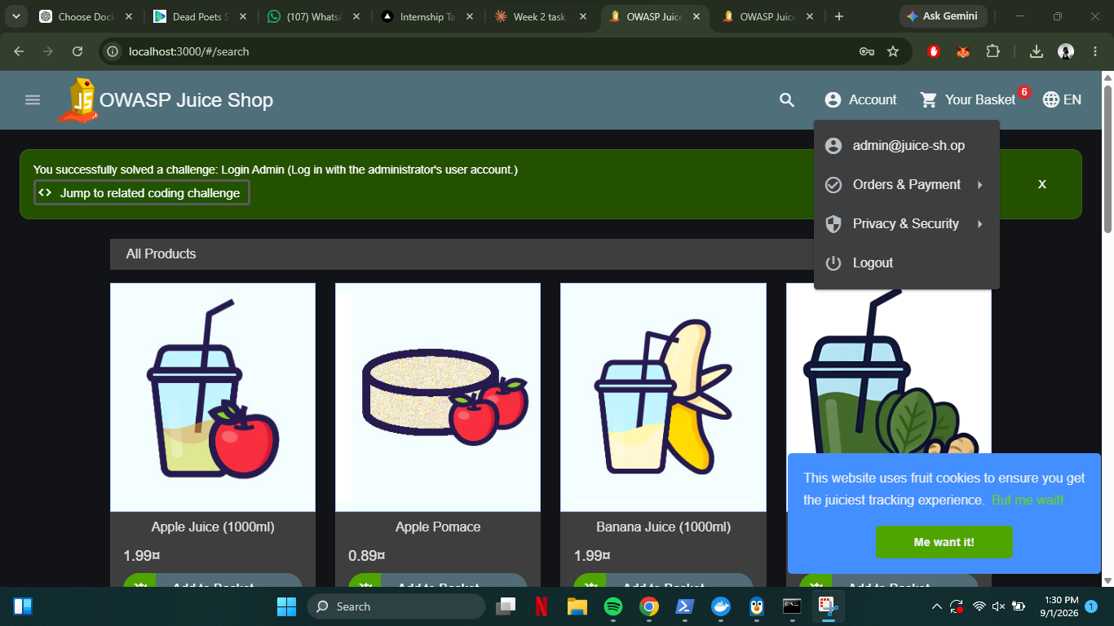
Figure 2: Successful login as admin@juice-sh.op — the challenge notification confirms 'Login Admin' was solved.

Challenge 2 — Cross-Site Scripting (XSS): DOM XSS
Cross-Site Scripting occurs when user-supplied input is inserted into a web page without proper sanitization, allowing an attacker to inject and execute arbitrary code in the context of the victim's browser. This challenge targeted a DOM-based XSS vulnerability in the site's product search feature.
Search field: <iframe src="javascript:alert(`xss`)">
The search feature reflects the query string directly into the page's DOM without filtering it. By submitting an <iframe> tag with a javascript: URI as its source, the browser executed the embedded script as soon as the page rendered the injected HTML, producing a JavaScript alert box.
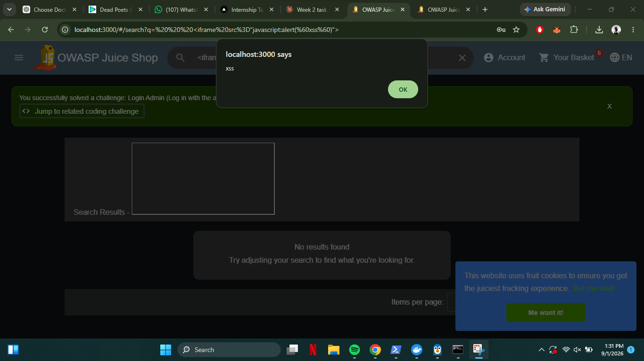
Figure 3: JavaScript alert box triggered via the injected iframe payload in the search bar, confirming the DOM XSS vulnerability.

Verification via Score Board
Both challenges were independently verified using Juice Shop's Score Board, which lists every challenge along with its solved/unsolved status, difficulty rating, and category.
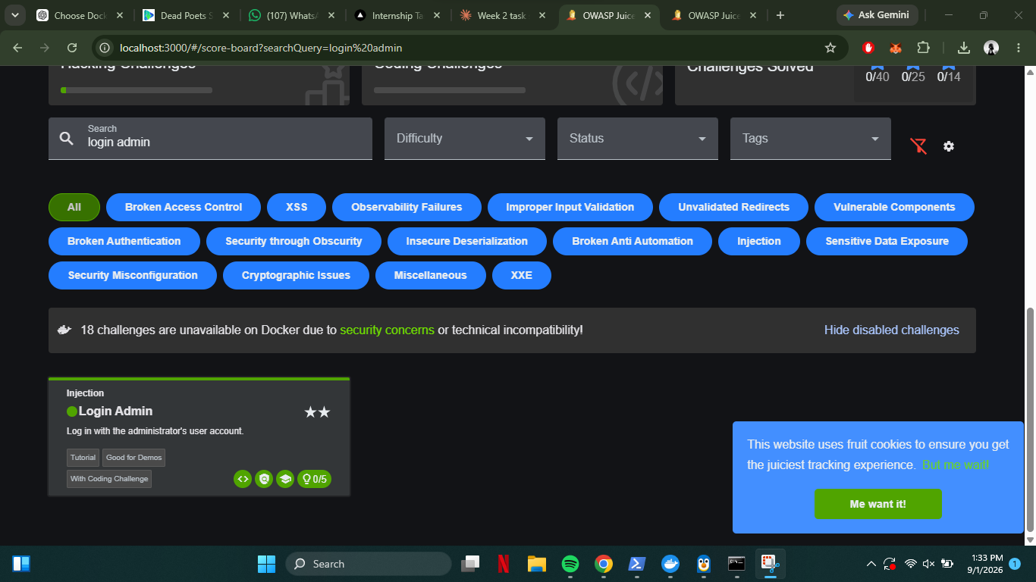
Figure 4: Score Board confirming the 'Login Admin' (SQL Injection) challenge is marked as solved (green indicator).
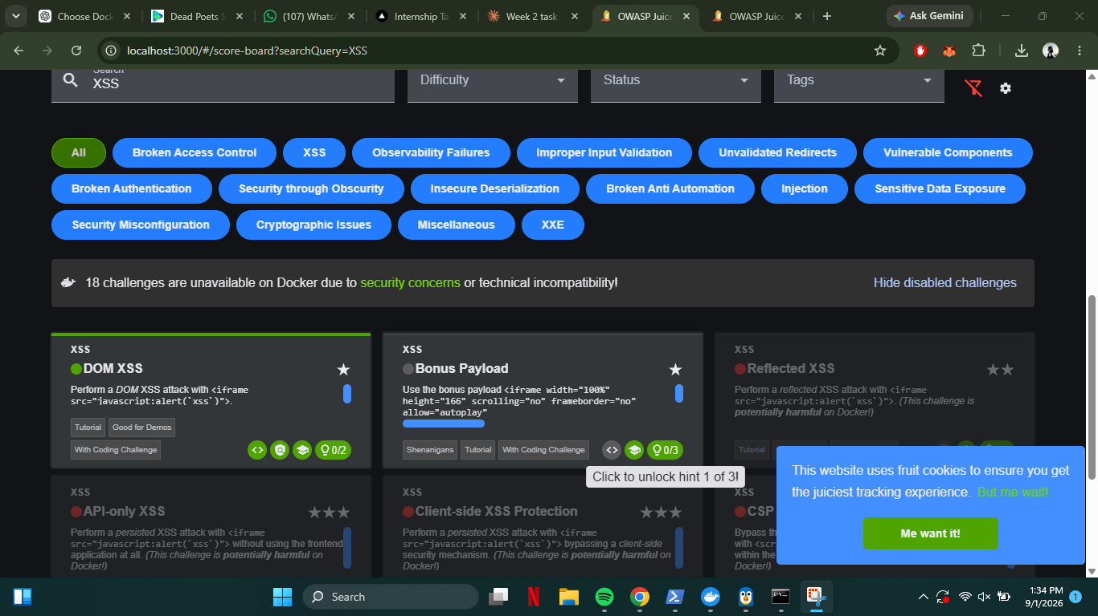
Figure 5: Score Board confirming the 'DOM XSS' challenge is marked as solved (green indicator, filled star icon).

4. Challenges Faced
• Initial setup issues with Docker Desktop: the application first failed to start due to an incomplete WSL2 (Windows Subsystem for Linux) installation, producing a 'wsl.exe --version' error. This was resolved by running 'wsl --install --no-distribution' and 'wsl --update' in an elevated PowerShell session, followed by a system restart.
• The hosted public demo instance of Juice Shop was occasionally slow or unavailable due to shared traffic, which was why a local Docker deployment was ultimately used instead, giving a private, dedicated instance of the application.

5. Key Learnings
• How SQL Injection exploits unsanitized input to alter the logic of backend database queries, and how comment sequences like '--' can be used to bypass parts of a query.
• How Cross-Site Scripting allows injected HTML/JavaScript to execute in a victim's browser when input is reflected into the DOM without sanitization.
• The practical difference between authentication bypass (SQLi) and client-side code execution (XSS) as two distinct classes of web vulnerability.
• How to deploy an intentionally vulnerable application safely and locally using Docker, isolating all testing from any live system.
• The importance of input validation and parameterized queries as real-world defenses against both vulnerability classes.

6. Conclusion
Both beginner-level challenges — the SQL Injection login bypass and the DOM-based XSS attack — were completed successfully on OWASP Juice Shop and confirmed via the application's Score Board. This exercise provided direct, hands-on insight into how two of the most prevalent web application vulnerabilities are exploited in practice, reinforcing the importance of proper input validation and output encoding in secure application design. All testing was performed exclusively against the local, sandboxed Juice Shop instance, in accordance with the task's safety guidelines.

